Carmen Mendoza

Module 5.2

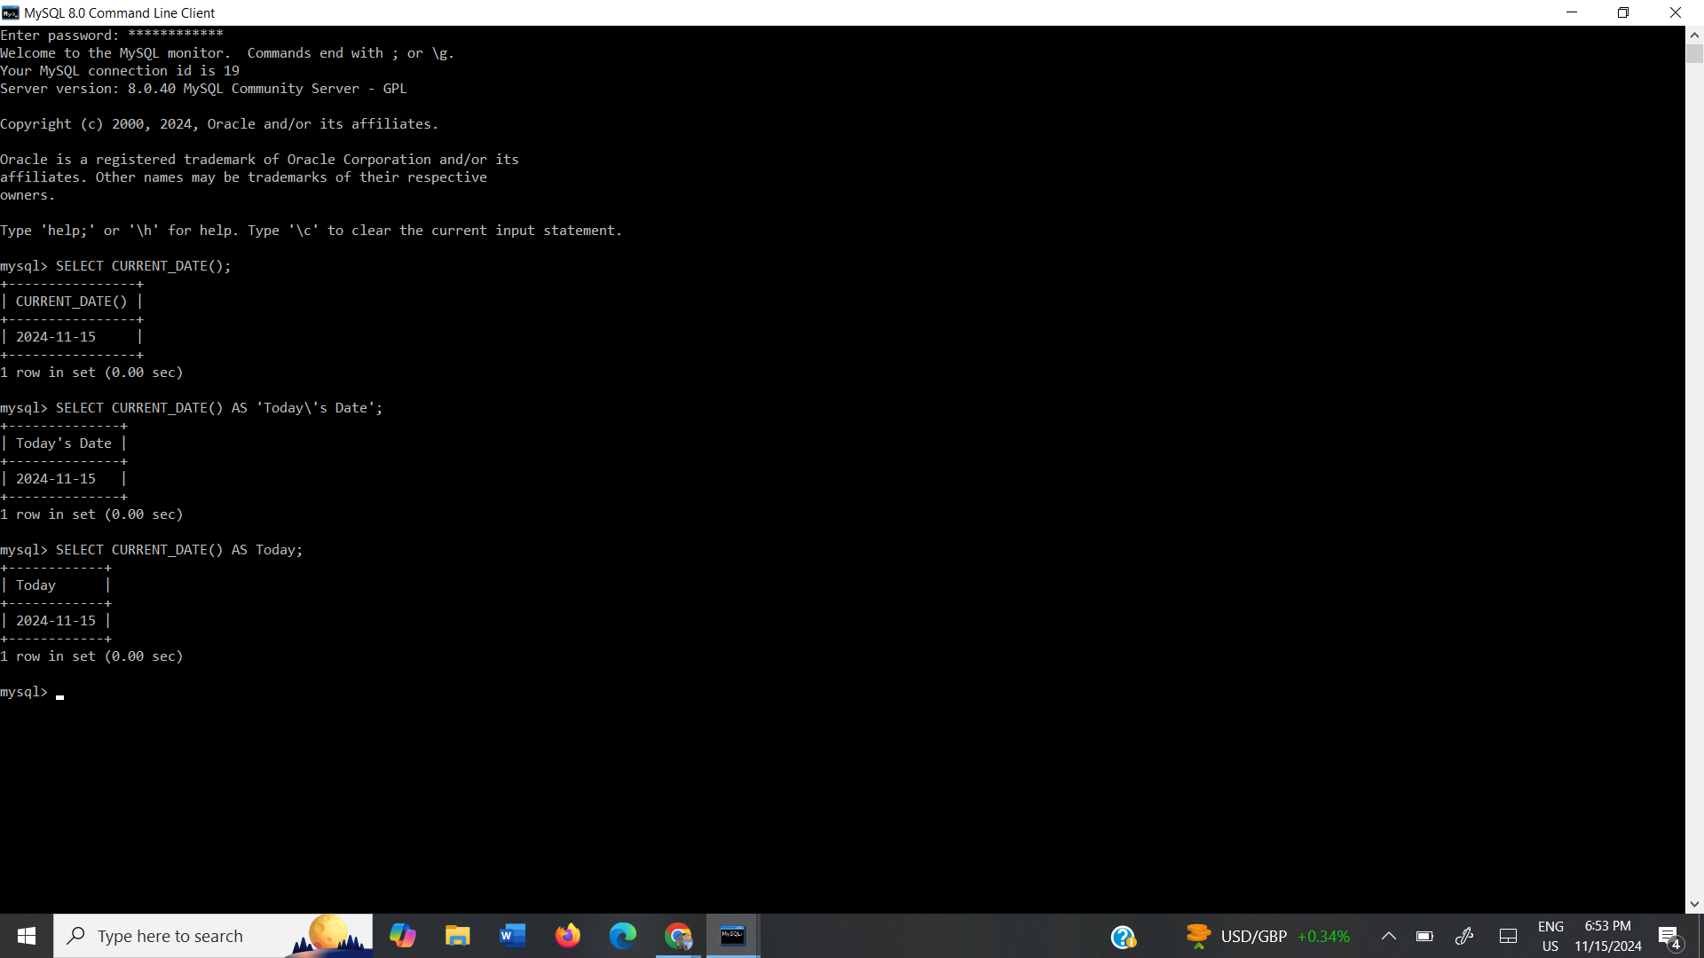

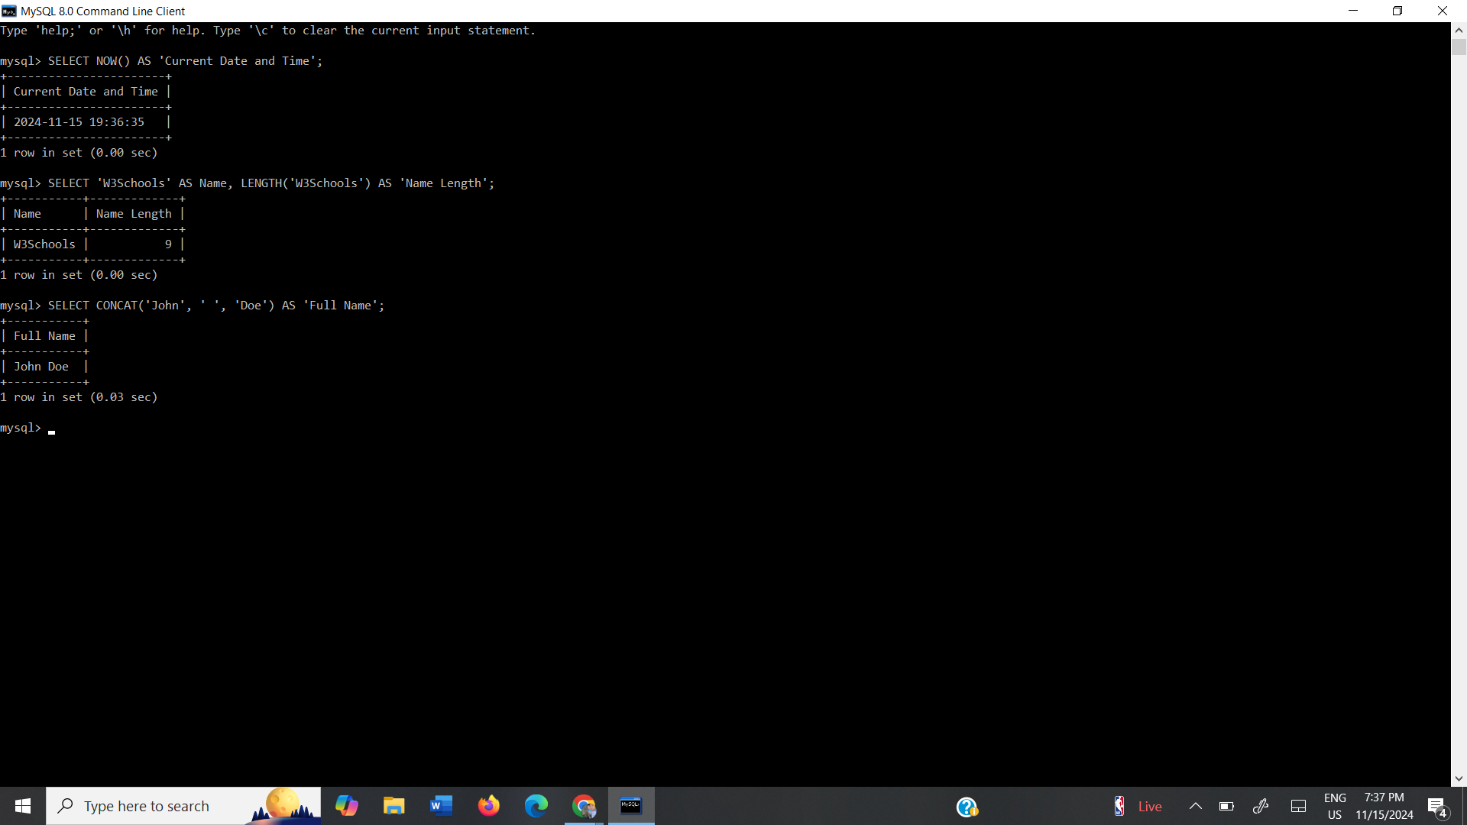

Function 1: NOW

The NOW function is used to retrieve the date and time in the format YYYY-MM-DD. It is common for logging events and timestamps for databases and tracking system operations. Alias: Current Date and Time

Function 2: LENGTH

LENGTH is used to calculate the number of characters in a string (in bytes). This would be used for validating data such as ensuring input meets length requirements.

Alias: Name Length

Function 3: CONCAT

CONCAT function adds two or more strings together. It is useful for creating full names or addresses.

Alias: Full Name

References:

(n.d.). *MySQL* *NOW() Function*. W3schools. <https://www.w3schools.com/sql/func_mysql_now.asp>

(n.d.). *MySQL* *LENGTH() Function*. W3schools. <https://www.w3schools.com/sql/func_mysql_length.asp>

(n.d.). *SQL Server* *CONCAT() Function*. W3schools. https://www.w3schools.com/sql/func_sqlserver_concat.asp